**Df last meeting:**

* Had duplicate games (1 from each team’s perspective)
* Had non-conference game data (where 1 of the teams in SEC and 1 not in SEC)

**Df now:**

* Removed games where both teams were not in the SEC
* Created Home Score and Away Score
* Separated stats by Home team and away team
* Created 3 dataframes from df:
  + Away for past games (W-L not null) and contains away stats
  + Home for past games and contains home stats
  + Upcoming for games that haven’t been played yet (no home/away stats)
* Merged Away and Home dfs
* Removed duplicated columns

**New problem -joining main df with other tables**

Example: ESPN (next page) needs to merge with upcoming games, since it’s only relevant to the next weeks

games. To do so, needed to first get the Upcoming games df with one game per row like main df(above)

Upcoming games df

* Removed duplicate games
* Split into 3 dataframes:
  + No Ranked Teams
  + Away Team Ranked
  + Home Team Ranked
* Merged Away and Home dfs

Problem is the merged data only includes teams that are both ranked doesn’t include games where both teams don’t have any team ranked

Home Ranked df

No Teams Ranked df

Away Ranked df

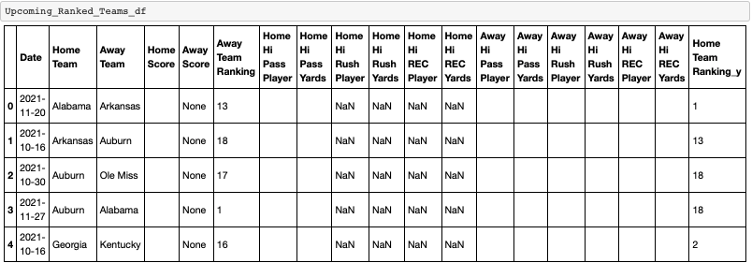

ESPN Before

ESPN Now

**Other upcoming datasets to merge**

